Janice Yan and Tovah Kashetsky

April 27th 2021

BIO 708 QMEE

**Exploring the social consequences of sexual conflict through bedbug (*Cimex lectularius*) social networks**

**Introduction**

**Background**

Sexual conflict occurs when the reproductive interests of the two sexes are at odds with one another (Parker, 1979; Chapman, 2006). This conflict is pervasive among sexual species and often involves behaviours and adaptations that provide benefits to one sex at the detriment of the opposing sex (Chapman, Arnqvist, Bangham, & Rowe, 2003). As a result of sexual conflict, females often experience sexual harassment, where males repeatedly pursue and coerce them into mating (Parker & Clutton-Brock, 1995). Sexual harassment has been shown to be detrimental to females through the energetic costs of resisting unwanted male attention (Watson, Arnqvist, & Stallmann, 1998), reduced foraging opportunities (Stone, Road, & Ox, 1995), and physical injury (Baniel, Cowlishaw, & Huchard, 2017). Together, these costs can often result in reduced longevity and fitness (Meader & Gilburn, 2008; Sakurai & Kasuya, 2008).

In response to sexual harassment and its associated costs, females are under strong selective pressures to evolve behavioural avoidance strategies among other physiological or morphological counter-adaptations to harmful male pursuit. Additionally, sexual harassment is expected to differentially affect the cost-benefit analyses associated with engaging in affiliative relationships for the two sexes. This can be key in facultatively or weakly social animals where the benefits of engaging in social interactions are either limited, context-dependent, or not well understood. All in all, sexual harassment and females’ responses to unsolicited, harmful mating attempts can have profound effects on population social structure, the fitness benefits related to group-living, and the evolution of sociality.

Bedbugs (*Cimex lectularius)* are an ideal model for studying the social implications of sexual conflict because of their notably harmful mode of copulation—traumatic insemination, where males use their copulatory organ to pierce females through their abdomen and deposit sperm into their body cavity. Repeated traumatic inseminations have been shown to reduce female longevity and lifetime reproductive output likely due to the increased energetic costs of wound healing and increased likelihood of infection (Morrow & Arnqvist, 2003; Stutt & Siva-Jothy, 2001). Additionally, bedbugs, a sub-social insect species, are typically found in aggregations mediated by an aggregation pheromone (Hentley, Webster, Evison, & Siva-Jothy, 2017). However, unlike in highly social insects, bedbugs are not dependent on living in social groups and can be found alone as well (Pfiester, Koehler, & Pereira, 2009). Therefore, the high costs of repeated matings can strongly impact female social preferences. All in all, tracking bedbug aggregations over time presents us with a unique opportunity to study how sexual conflict and harassment differentially affect social tendencies in the two sexes and how these differences in social behaviour affect mating outcomes and overall population social structure.

**Brief Overview of Methods**

To examine the impact of sexual harassment on social structure, we devised a novel experimental arena that provided bedbugs with either 2 or 12 shelters and an artificial “host” (blood source) to facilitate natural foraging behaviour. Through live observations, we continuously tracked sexual and social interactions between groups of 24 (12 male, 12 female) individually marked bedbugs for eight hours a day, six days in a row. Using social network analysis, we created social networks based on aggregations and mating to examine several predictions regarding the relationship between sexual conflict and social behaviour.

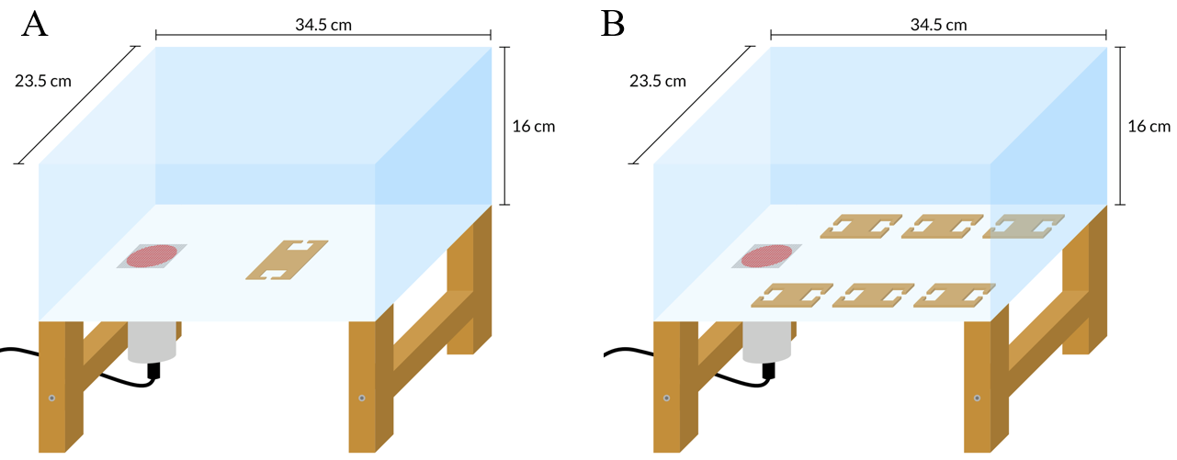

**Figure 1.** Side-view of our experimental arena. A) Two-shelter treatment. B) Twelve-shelter treatment.

**Predictions**

Using measures from the social networks, we tested several predictions aimed at assessing whether females have evolved behavioural strategies for evading harassment from males and costly traumatic matings. Firstly, we predicted that females would be less sociable than males as females would be subjected to sexual harassment and repeated mating attempts when participating in large aggregations. This hypothesis is supported by the finding that bedbugs of all ages and both sexes appear to release an attractive aggregation pheromone except for when females are recently mated (Siljander et al., 2007). On the contrary, males have the added benefit of increased mating opportunities if they are to join large groups and thus should have stronger social tendencies. Secondly, we predicted that networks would show sex-based assortativity as preferentially associating with same-sex individuals could allow females to exploit the benefits of aggregation without enduring the increased cost of harassment from males. Thirdly, we predicted that the amount of harassment a female receives would increase as a function of her overall sociability because females in the presence of males are likely exposed to more mating attempts. Lastly, we predicted that the effects of prediction 1 and 3 would be stronger in the 12-shelter treatment compared to the 2-shelter treatment because the 12-shelter treatment provides females with the ability to use our hypothesized social avoidance strategies.

**Statistics and Results**

We use the file bedbugs_main.R for our script.

**Social Network Analysis**

We constructed two networks for each population. The nodes of each network represent individual bedbugs, while weighted edges represent either association indices between dyads in aggregation networks (Fig 2) or number of matings in harassment networks (Fig 3). The purpose of the association index is to estimate the proportion of time two individuals spent in the same aggregation based on our hourly scans. Specifically, we used the simple ratio index (SRI) described in Hoppitt and Farine (2018) which is recommended for when every animal is reliably recorded in every sampling period. While we also recorded mountings (mating attempts), we ultimately decided to quantify harassment through the number of matings a female receives as it has known fitness costs (Benoit, 2011; Morrow & Arnqvist, 2003; Reinhardt, Naylor & Siva-Jothy, 2003). We believe matings serve as a good indicator of harassment received as female bedbugs can maintain maximum fecundity with only one mating per month (Stutt & Siva-Jothy, 2001), are not known to gain any fitness benefits from multiple matings, and all females in our experiment mated at least once.   
 To quantify individual sociability, we extracted strength values from the aggregation network which is the sum of all edge weights connected to a node and represents how often and with how many others an individual bedbug was typically seen aggregating with. To quantify harassment, we used the number of matings that females received which is also equivalent to individual strength in the mating networks.

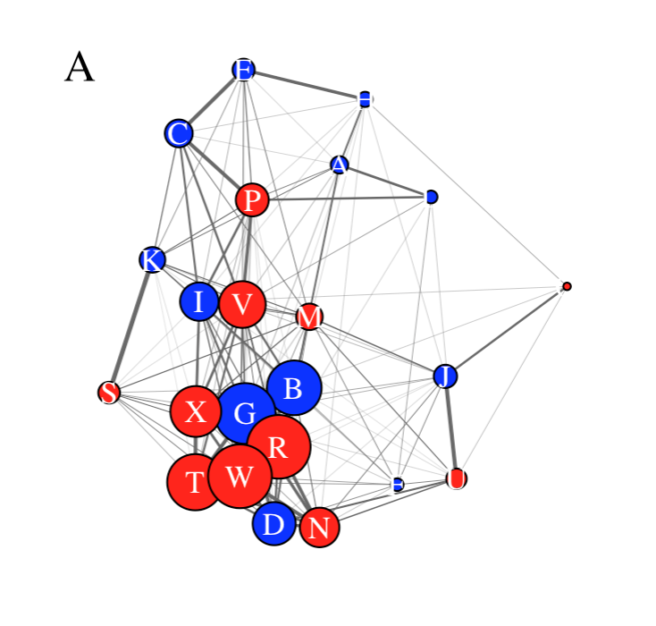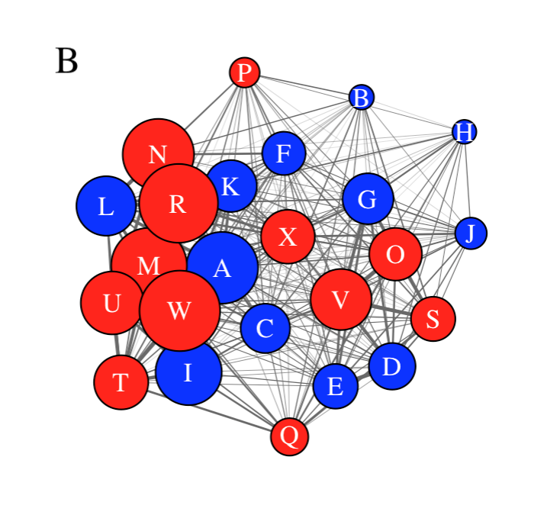

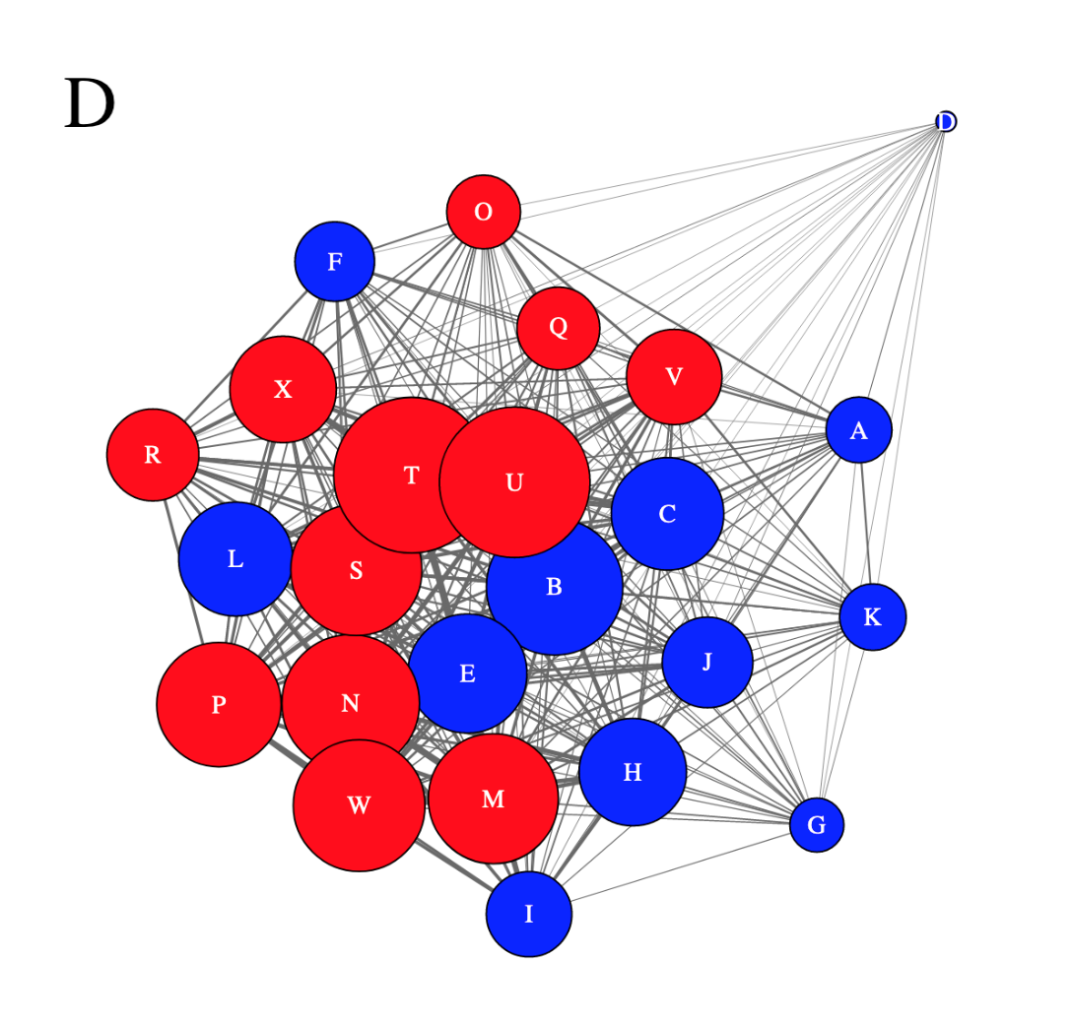

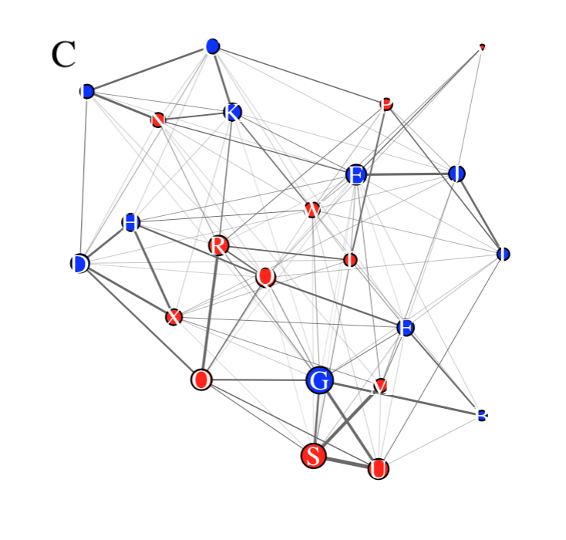

**Figure 2.** Aggregation networks for block 1 (A & B) and block 2 (C & D), with the 12-shelter treatment (A & C) and 2-shelter treatment (B & D). Nodes represent strength (size) and sex (blue=male, red=female). Nodes in network D are at half the scale as networks A, B and C because they have strong sociability values, making it difficult to read at the same scale as the others. Weighted edges indicate association index values.

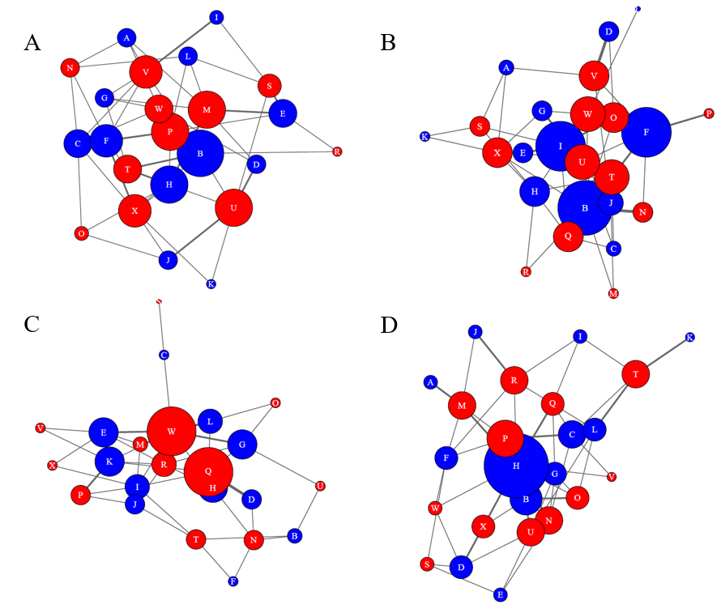

**Figure 3.** Harassment networks for block 1 (A & B) and block 2 (C & D), with the 12-shelter (A & C) and 2-shelter treatment (B & D). Nodes represent strength (size) and sex (blue=male, red=female). Weighted edges represent the number of matings.

**Prediction 1: Males will be more social than females**

We tested whether males were more social than females using a generalized linear model (GLM) and a permutation test. For the GLM, strength (from the aggregation network) was the response variable while sex, size, replicate (network) and treatment were predictors and fixed effects, and we used the Gamma family. We did not have any random effects. Once there are three blocks, block could be a random effect. Diagnostic plots showed that our model fit very well.

Because measures obtained from social networks are inherently non-independent, thus violating the assumptions underlying most parametric tests (Croft et al., 2011), we performed permutation tests where networks are randomized using the observed data to obtain true p-values for all of our predictions. We approached this by using node-label permutations where the nodes (individuals) were shuffled and re-distributed among the possible node positions in the observed networks. This is a commonly used approach for assessing whether nodes with different attributes reliably occupy different network positions (central/more social vs. peripheral/less social) (Farine and Whitehead, 2015). While it often makes sense to impose some constraints on the randomization based on biological factors such as how quickly/often individuals can move between refuges or whether certain types of individuals tend to stay put in their nest or home range, we could not think of any obvious constraints that would bias movement and aggregating based on our setup and observations.   
 For prediction 1, we performed this node-label randomization on all four aggregation networks thus generating new strength values for each bedbug. We then re-ran our GLM using these newly obtained strength values and extracted the model coefficient for effect of sex on strength (sexMale in the Rscript). We repeated this process where the networks are shuffled and new strength values are fed into the GLM a thousand times resulting in a distribution of model coefficients representing the null hypothesis where there is no sex difference in sociability. By comparing the observed model coefficient for effect of sex on strength to this null distribution, we obtained a p-value by calculating a one-tailed p-value for the observed effect and then doubling the p-value to represent a two-tailed test.

**Prediction 1 results:**

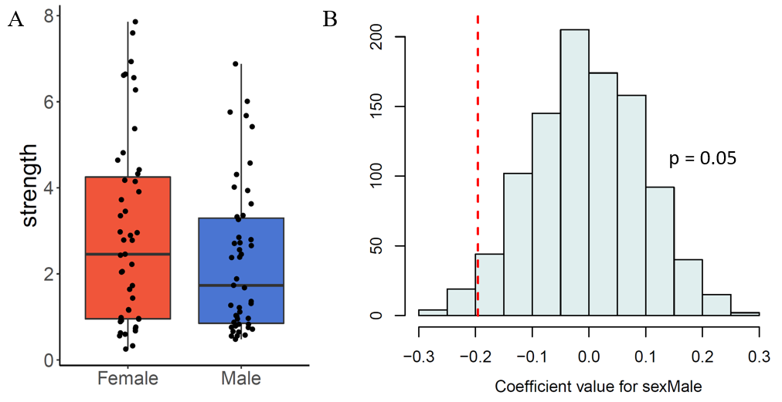

**Figure 4.** A)Boxplot of strength derived from aggregation-based networks for males (N = 47) vs. females (N = 47). B) Distribution of model coefficient values comparing male vs. female strength from the permutation test with the red dotted line indicating our observed model coefficient (-0.2).

We found that females were on average more social than males (p = 0.05; Fig. 4) which was the opposite of what we initially predicted. However, it should be noted that we are still waiting for data from an additional block of experiments which can affect how clearly we can interpret results.

**Prediction 2: Networks will show positive sex-based assortment**

Here, we wanted to examine whether bedbug populations showed positive assortment by sex with the rationale being that females may preferentially seek out same-sex individuals when joining aggregations to avoid sexual harassment. To do this, we calculated the assortativity index (AI) for each of our four networks. AI is a value between -1 and 1 where 1 represents perfect assortativity, -1 represents disassortativity, and 0 indicates no assortment. We calculated network assortativity by using the assortment.discrete function from the R package assortnet which takes into account edge weights (Farine, 2014). We then performed 1000 iterations of a node-label permutation for each of our four observed networks where a new AI is calculated each time the individuals of a network were shuffled. This resulted in a distribution of 1000 AI’s for each of our four bedbug populations under the null hypothesis that associations between individuals were completely random (not biased by sex). By comparing observed AI’s for each network to its respective null distribution of AI’s, we obtained a p-value for each population by calculating a one-tailed p-value for the observed effect and then doubling the p-value to represent a two-tailed test.   
  
**Prediction 2 results:**

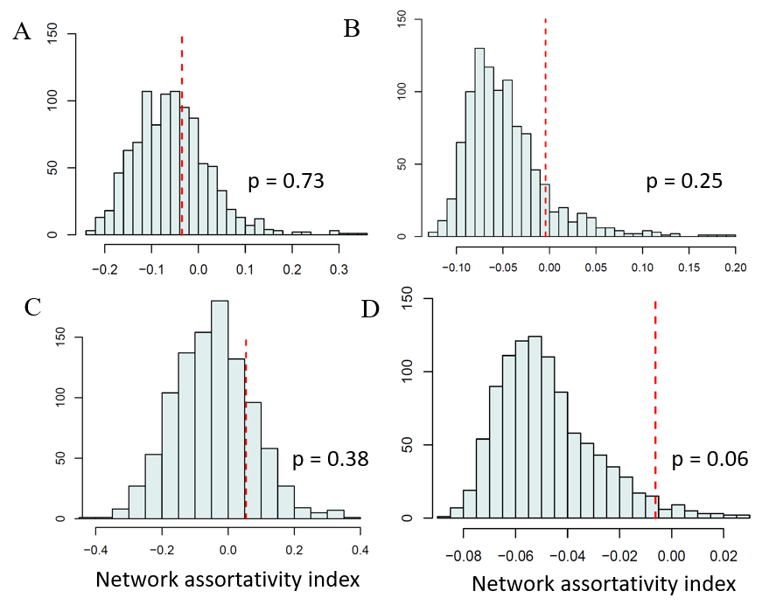

**Figure 5.** Distribution of assortativity indexes from permuted two-shelter networks (A and C) and 12-shelter networks (B and D). Distributions A and B are from Block 1 while distributions C and D are from block 2. The red dashed line represents observed assortativity indexes.

In each of our four bedbug populations, observed assortativity indexes were close to zero, indicating no preference for aggregating with same-sex vs. opposite sex individuals. Additionally, our permutation tests revealed that observed networks were not significantly more assorted than would be expected at random (Fig.5). Overall, our data does not support the hypothesis that females can successfully aggregate with predominately same-sex individuals as a means to avoid harassment from males.

**Prediction 3: Harassment of females will increase as a function of sociability**

As we were interested in harassment received by females for this prediction, the tests and data shown are only from female bedbugs. We tested prediction three with a GLM and permutation test using measures from the sociability and harassment networks. All females mated at least once, with a mean of 4.96. For the GLM, number of matings was the response variable while strength, sex, network and treatment were predictors and fixed effects, and we used the Gamma family. We did not have any random effects. Once there are three blocks, block could be a random effect. Diagnostic plots showed that our model fit very well.

Similar to in prediction 1, we tested for statistical significance by performing node-label permutations on our observed networks and running the GLM on new node attributes obtained after network randomizations. We approached the permutations by only shuffling the females in the mating network so that any single female could occupy any network position that any other female had occupied. This meant that after each randomization, females received a new harassment score (or new # of matings) while maintaining their original strength value from aggregation-based networks. This represents the null hypothesis that there is no specific relationship between female sociability and harassment received.

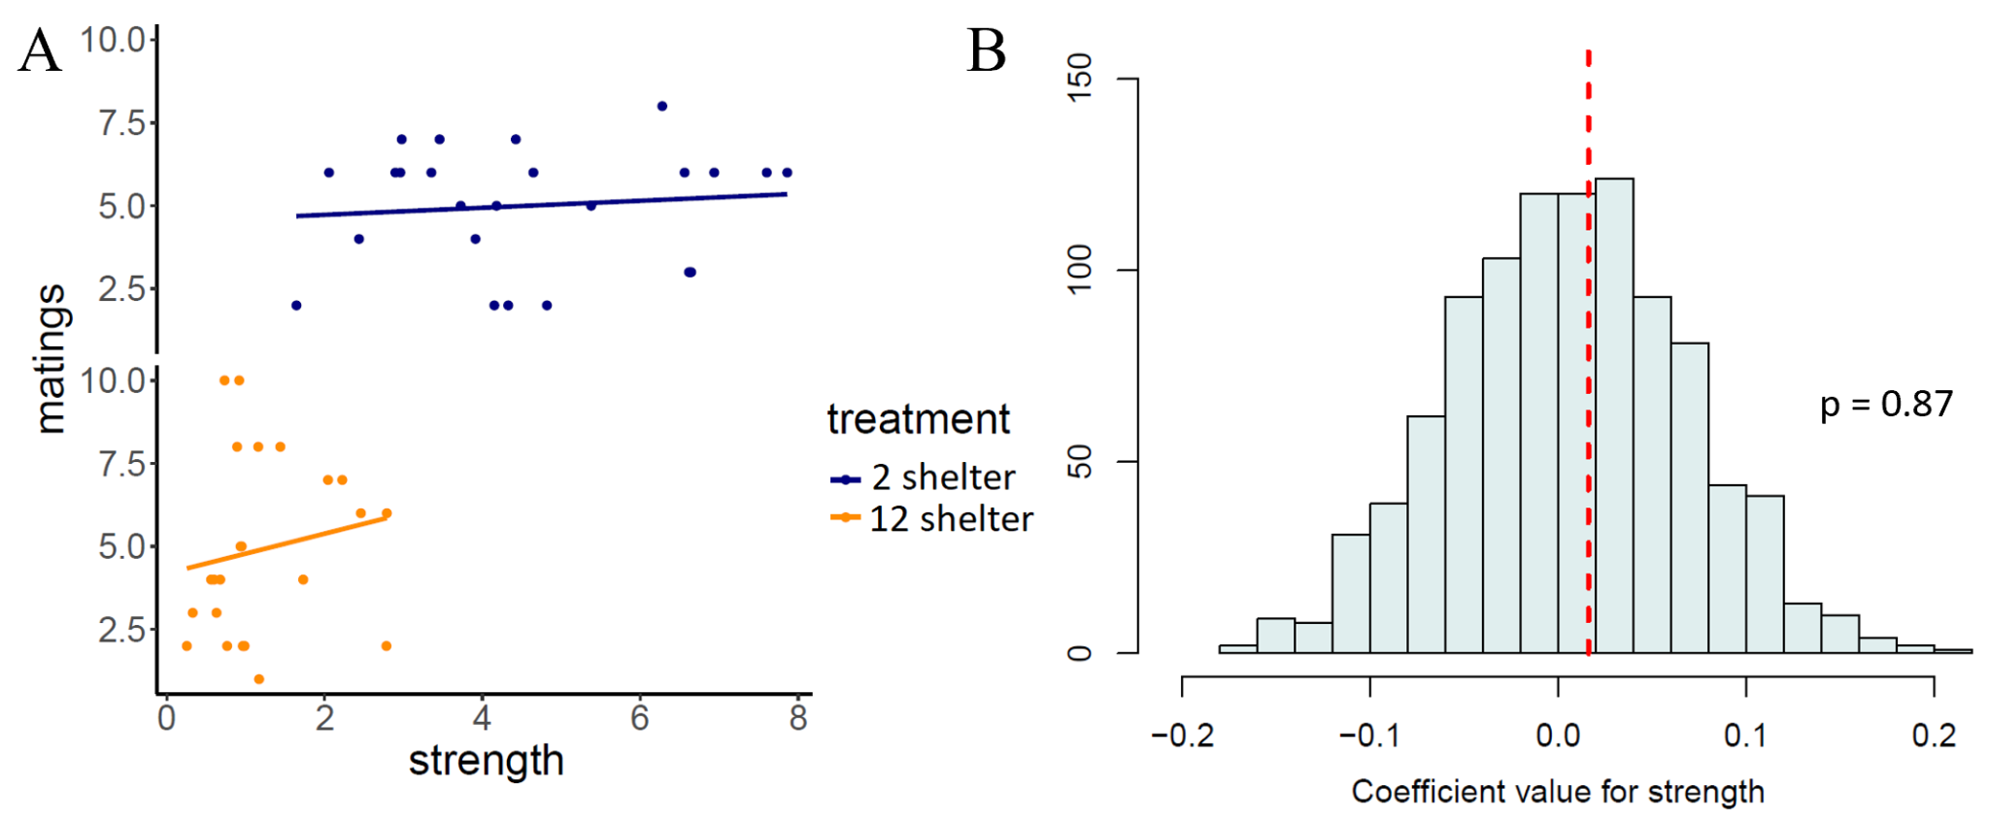

**Figure 5.** A) Scatterplot showing raw data for the relationship between strength, our measure of sociability, and the number of matings a female received (N = 24 for the 2-shelter treatment and N = 23 for the 12-shelter treatment). B) Distribution of model coefficients for the effect of strength on matings obtained from running our GLM on randomized networks where the red dashed line represents the observed effect of strength on matings.   
  
 We found that individual sociability, measured by strength from the aggregation-based network, was not a reliable predictor for the amount of harassment received by females. Specifically, through the permutation test, the effect of strength on number of matings was neither higher or lower than would be expected by chance (p = 0.87; Fig.5B). This may suggest that we have overestimated the cost of sexual harassment that a female endures when participating in large social groups.

**Prediction 4: Effects of P1 and P3 will be stronger in the low sexual conflict treatment compared to the high sexual conflict treatment**

We tested prediction four with two GLMs and permutations using measures from the sociability and harassment networks. The first GLM (P1) tested strength as the response variable, with a sex*treatment interaction, with size, network and block as fixed effects. The second GLM (P2) tested matings as the response variable, with a strength*treatment interaction, with size, network and block as fixed effects. Both sets of diagnostic plots suggest our model fits very well.

We have not yet implemented the permutation test for this prediction as we are unsure of how to shuffle our data in a way that accurately reflects the null hypothesis of our GLM. However, our inclination is to allow all nodes to be shuffled amongst possible node positions from all four of our observed networks with the only constraint being that each network maintains the same number of males and females. For prediction 1, we would only shuffle individuals for aggregation-based networks so that each individual receives a new randomized sociability score (strength). For prediction 3, we would just shuffle the females amongst the possible female positions from all four mating networks so that each female receives a new randomized number of matings score.

**Conclusion and Future Directions**

Overall, we did not find clear evidence that females avoid harassment from males either by being less social overall or by forming female-biased aggregations. Our data also does not support our prediction that more social females would suffer from more sexual harassment. It is possible that the intensity of sexual conflict in bedbugs is overestimated and thus, females do not require social avoidance strategies to mitigate the cost of traumatic insemination. This could be because males already achieve maximal mating rate due to seminal fluid constraint (Reinhardt et al., 2001) through actively roaming the arena to find females and thus, aggregating with males does not lead to additional costs. Another possibility is that females have alternative behavioural tactics for preventing unwanted matings such as the hypothesized “refusal posture” that eliminates the need for social avoidance (Siva-Jothy, 2006). Therefore, it would be valuable to explore our data on mounting (mating attempts) and female behavioural responses to these attempts.

Contrary to our prediction, females do appear to be more social than males overall as they had higher strength values in aggregation-based networks (p = 0.05). However, we will have to wait until after we obtain data from Block 3 to see if this pattern still holds. If we do see clear evidence that females consistently have stronger social associations, we still would not know if this is due to females seeking more connections or conspecifics preferring to interact with females over males. To disentangle these possibilities, we are considering a follow-up experiment that directly assesses social preferences of virgin and mated males and females while also using scent cues of females vs. males to test for differential attractiveness.   
We were unable to figure out how to obtain confidence intervals for our permutation tests but they would be valuable for distinguishing between whether our effects are not statistically clear due to a small sample size or if effects are just small. To obtain confidence intervals for permutation tests, we would have to make several underlying assumptions about the distribution from which the data was drawn or in the case of prediction three, we would have to make an assumption about the true relationship between sociability and harassment. However, since this is the first time (to our knowledge) that individual sociability of bedbugs is being quantified, we do not have any solid information to guide our assumptions. Furthermore, our unexpected observation that bedbugs were very weakly social in the 12-shelter treatment is an indication that our prior estimate of bedbug sociality may have been overinflated. For these reasons, we are really unsure of how to approach confidence intervals for our predictions.

**Works cited**

Baniel, A., Cowlishaw, G., & Huchard, E. (2017). Male Violence and Sexual Intimidation in a

Wild Primate Society. *Current Biology*, *27*(14), 2163-2168.e3.

<https://doi.org/10.1016/j.cub.2017.06.013>

Benoit, J. B., Jajack, A. J., & Yoder, J. A. (2012). Multiple traumatic insemination events reduce the  
 ability of bed bug females to maintain water balance. *Journal of Comparative Physiology B:  
 Biochemical, Systemic, and Environmental Physiology*, *182*(2), 189–198.

Cappozzo, H. L., Túnez, J. I., & Cassini, M. H. (2008). *Sexual harassment and female*

*gregariousness in the South American sea lion , Otaria flavescens*. *7*, 625–630. https://doi.org/10.1007/s00114-008-0363-2

Chapman, T. (2006). Evolutionary Conflicts of Interest between Males and Females. *Current  
 Biology*, *16*(17), 744–754. https://doi.org/10.1016/j.cub.2006.08.020

Chapman, T., Arnqvist, G., Bangham, J., & Rowe, L. (2003). Sexual conflict. *Trends in Ecology  
 and Evolution*, *18*(1), 41–47.

Croft DP, Madden JR, Franks DW, James R (2011b) Hypothesis testing in animal social  
 networks. Trends Ecol Evol 26:502–507

Dadda, M. (2015). Female social response to male sexual harassment in poeciliid fish: a  
 comparison of six species. *Frontiers in Psychology*, *6*(September), 1–9.  
 https://doi.org/10.3389/fpsyg.2015.01453

Darden, S. K., & Croft, D. P. (2008). Male harassment drives females to alter habitat use and  
 leads to segregation of the sexes. *Biology Letters*, *4*(5), 449–451.  
 <https://doi.org/10.1098/rsbl.2008.0308>

Farine, D. R. (2014). Measuring phenotypic assortment in animal social networks: Weighted  
 associations are more robust than binary edges. *Animal Behaviour*, *89*, 141–153.  
 https://doi.org/10.1016/j.anbehav.2014.01.001

Farine, D. R., & Whitehead, H. (2015). Constructing, conducting and interpreting animal social  
 network analysis. *Journal of Animal Ecology*, *84*(5), 1144–1163.  
 https://doi.org/10.1111/1365-2656.12418

Fox, E. B. A. (2002). Female tactics to reduce sexual harassment in the Sumatran orangutan  
 (*Pongo pygmaeus abelii*). *Behavioral Ecology and Sociobiology*, *52*(2), 93–101.  
 https://doi.org/10.1007/s00265-002-0495-x

Hentley, W. T., Webster, B., Evison, S. E. F., & Siva-Jothy, M. T. (2017). Bed bug aggregation on  
 dirty laundry: A mechanism for passive dispersal. *Scientific Reports*, *7*(1), 1–5.  
 https://doi.org/10.1038/s41598-017-11850-5

Martens, A., & Rehfeldt, G. (1989). Female aggregation in Platycypha caligata (*odonata:  
 chlorocyphidae*): a tactic to evade male interference during oviposition. *Animal  
 Behaviour*, *38*(3), 369–374. https://doi.org/10.1016/S0003-3472(89)80029-6

Meader, S. J., & Gilburn, A. S. (2008). Asymmetrical costs of sexual conflict in the seaweed fly,  
 *Coelopa frigida*. *Ecological Entomology*, *33*(3), 380–384.  
 https://doi.org/10.1111/j.1365-2311.2007.00980.x

Morrow, E. H., & Arnqvist, G. (2003). Costly traumatic insemination and a female  
 counter-adaptation in bed bugs. *Proceedings of the Royal Society B: Biological Sciences*,  
 *270*(1531), 2377–2381. https://doi.org/10.1098/rspb.2003.2514

Parker, G. A., & Clutton-Brock, T. H. (1995). Sexual coercion in animal societies. *Animal  
 Behaviour*, *49*(5), 1345–1365. https://doi.org/10.1006/anbe.1995.0166

Pfiester, M., Koehler, P. G., & Pereira, R. M. (2009). Effect of Population Structure and Size on  
 Aggregation Behavior of *Cimex lectularius* (Hemiptera: Cimicidae). *Journal of Medical  
 Entomology*, *46*(5), 1015–1020. https://doi.org/10.1603/033.046.0506

Pilastro, A., Benetton, S., & Bisazza, A. (2003). *Female aggregation and male competition  
 reduce costs of sexual harassment in the mosquitofish Gambusia holbrooki*. 1161–1167.  
 <https://doi.org/10.1006/anbe.2003.2118>

Reinhardt, K., Naylor, R., & Siva-Jothy, M. T. (2003). Reducing a cost of traumatic insemination:  
 Female bedbugs evolve a unique organ. *Proceedings of the Royal Society B: Biological  
 Sciences*, *270*(1531), 2371–2375.

Sakurai, G., & Kasuya, E. (2008). The costs of harassment in the adzuki bean beetle. *Animal  
 Behaviour*, *75*(4), 1367–1373. <https://doi.org/10.1016/j.anbehav.2007.09.010>

Siljander, E., Penman, D., Harlan, H., & Gries, G. (2007). Evidence for male- and  
 juvenile-specific contact pheromones of the common bed bug *Cimex lectularius*.  
 *Entomologia Experimentalis et Applicata*, *125*(2), 215–219.  
 <https://doi.org/10.1111/j.1570-7458.2007.00617.x>

Siva-Jothy, M. T. (2006). Trauma, disease and collateral damage: Conflict in cimicids.  
 *Philosophical Transactions of the Royal Society B: Biological Sciences*, *361*(1466),  
 269–275. https://doi.org/10.1098/rstb.2005.1789

Stone, G. N., Road, S. P., & Ox, O. (1995). Female foraging responses to sexual harassment in  
 the solitary bee *Anthophora plumipes*. 405–412.

Stutt, A. D., & Siva-Jothy, M. T. (2001). Traumatic insemination and sexual conflict in the bed  
 bug *Cimex lectularius*. *Proceedings of the National Academy of Sciences of the United  
 States of America*, *98*(10), 5683–5687. https://doi.org/10.1073/pnas.101440698

Watson, P. J., Arnqvist, G., & Stallmann, R. R. (1998). Sexual conflict and the energetic costs of  
 mating and mate choice in water striders. *American Naturalist*, *151*(1), 46–58.  
 https://doi.org/10.1086/286101